**Front End Engineering-II**

Project Report

Semester-IV (Batch-2022)

**COUNTDOWN TIMER**



**Supervised By: Submitted By:**

Mr. Raveesh Samkaria Sanidhya Chauhan

2210990786

G-12

**Department of Computer Science and Engineering Chitkara University Institute of Engineering & Technology,**

**Chitkara University, Punjab**

# Abstract

**"A countdown timer is a digital tool designed to measure and display the remaining time until a specified event or deadline. It typically presents the time in hours, minutes, and seconds, offering users a visual representation of time passing. Countdown timers are versatile and customizable, with options for setting durations, selecting alarm sounds, and personalizing appearances. They enhance productivity, efficiency, and time management across various activities and settings, aiding users in staying organized and meeting deadlines effectively."**

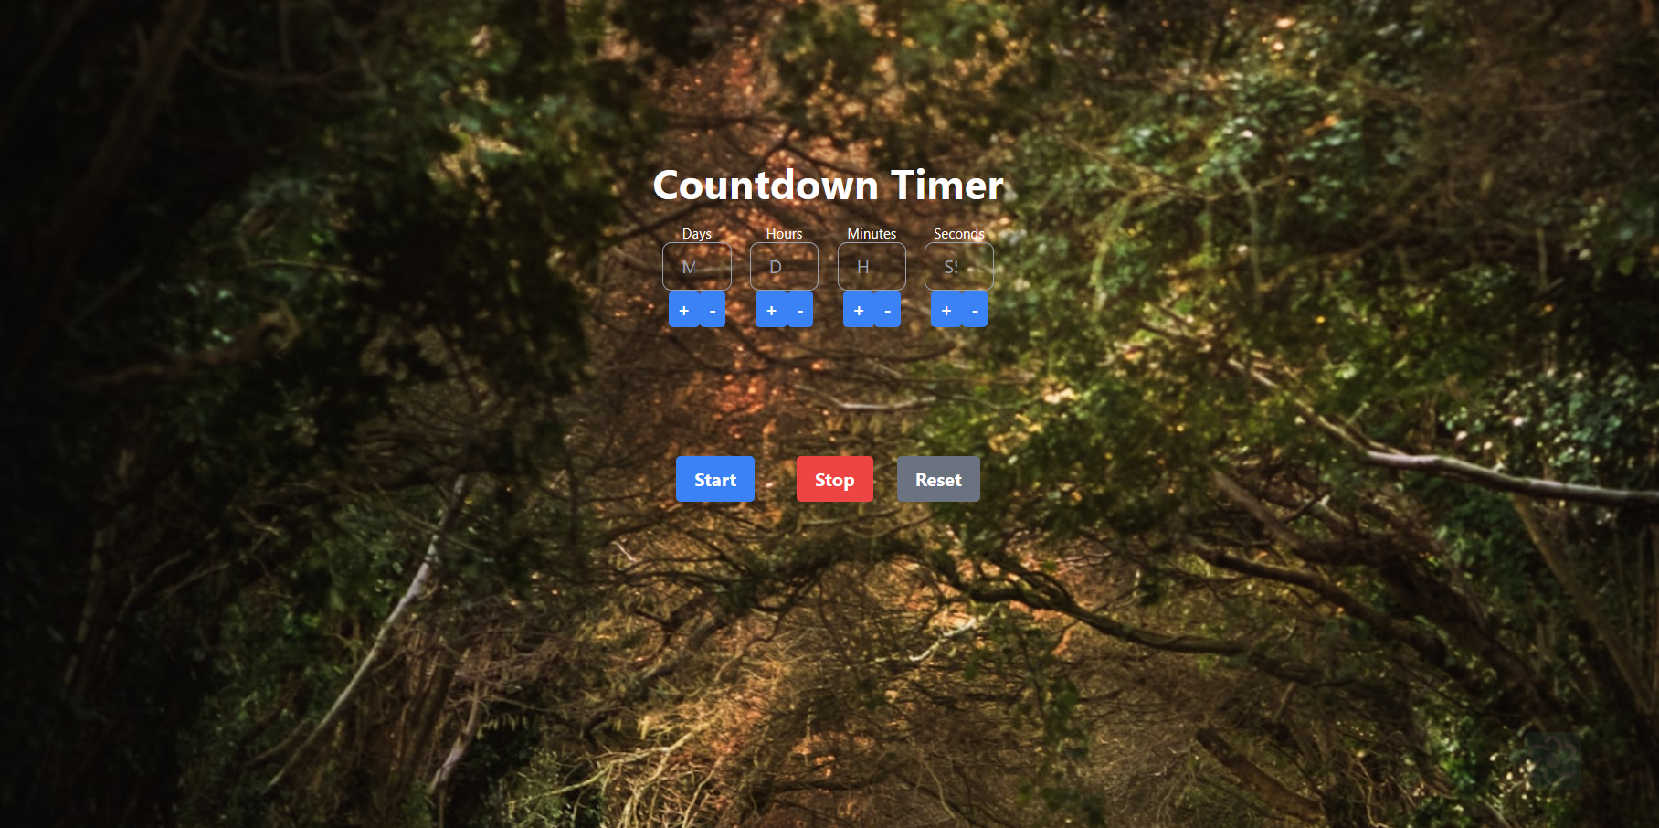

# INDEX

|  |  |  |
| --- | --- | --- |
| **S.No.** | **Title** | **Page Number(s)** |
| 1 | Introduction | 4 |
| 2 | Problem Statement | 5 |
| 3 | Software Requirements | 5 |
| 4 | Proposed Design | 6-13 |
| 5 | Results | 14-16 |
| 6 | References | 16 |

# Introduction

A countdown timer is a handy tool used to measure the remaining time until a specific event or deadline. Whether it's for a presentation, a cooking recipe, a workout session, or any other timed activity, countdown timers help users stay organized and focused by providing a visual representation of time passing.

Countdown timers typically display the time remaining in hours, minutes, and seconds, and some may even include milliseconds for precision. They can be found in various formats, including digital clocks, smartphone apps, websites, and standalone devices.

**1.1 Background:**

The background of the countdown timer dates back to the early 20th century when mechanical timing devices were first developed. Initially, these devices were primarily used in industrial and scientific settings to measure and control processes with precise timing requirements.

The concept of a countdown timer evolved with the advancement of technology, particularly with the advent of digital electronics. Electronic countdown timers began to emerge in the mid-20th century, offering greater accuracy, flexibility, and ease of use compared to their mechanical counterparts.

**1.2 Objectives:**

The objective of a countdown timer is to provide users with a visual representation of the remaining time until a specified event or deadline. Here are some key objectives of countdown timers:

1. Time Management: Countdown timers help users manage their time effectively by providing a clear indication of how much time is left until a particular task, event, or deadline.
2. Focus and Productivity: By creating a sense of urgency, countdown timers can enhance focus and productivity, encouraging users to stay on track and complete tasks within a set timeframe.
3. Organization and Planning: Countdown timers aid in organizing schedules and planning activities by allowing users to allocate specific amounts of time to different tasks or segments of an event.

**1.3 Significance:**

The significance of countdown timers lies in their ability to enhance productivity, efficiency, and time management in various aspects of life. Here are some key points highlighting their significance:

Time Awareness: Countdown timers create a heightened awareness of time, helping individuals better manage their schedules and prioritize tasks effectively.

Task Management: By visually representing the remaining time until a deadline or event, countdown timers assist in breaking down tasks into manageable segments, making it easier for individuals to allocate time appropriately.

# Problem Statement

The problem statement of a countdown timer typically addresses the need or challenge that the timer aims to solve or improve upon. Here's an example problem statement for a countdown timer:

"In today's fast-paced world, individuals often struggle with time management and staying organized amidst numerous tasks and deadlines. Traditional methods of tracking time, such as manual clocks or mental calculations, are prone to errors and inefficiencies. Additionally, individuals may experience heightened stress and anxiety when faced with looming deadlines or uncertain timeframes.

# Software Requirements

1. **Integrated Development Environment (IDE):** 
   * Visual Studio Code (VS Code) for code editing and project management.
2. **Frontend Technologies:** 
   * HTML: Markup language for structuring the web application.
   * CSS: Styling language for enhancing the presentation and layout.
   * JavaScript (JS): Programming language for implementing interactive features and quiz logic.
3. **User Interface (UI) Framework:** 
   * Tailwind CSS : Utility-first CSS framework for building responsive and customizable user interfaces.
4. **Version Control:** 
   * Git: Distributed version control system for tracking changes in the project codebase and collaborating with team members effectively.

# Proposed Design

* **User Interface Design:** Employ Tailwind CSS for a modern and responsive layout, focusing on simplicity and clarity.
* **Frontend Development:** Develop the quiz application using HTML, CSS, and JavaScript. Leverage HTML5 semantics for structural elements, CSS for styling, and JavaScript for dynamic functionalities such as ball , paddle movement and score keeping.
* **User Experience Optimization:** Prioritize user interaction by providing real-time feedback on answer selection. Implement smooth transitions and animations using Tailwind CSS utilities to enhance the overall user experience.
* **Testing and Quality Assurance:** Conduct rigorous testing, including both manual and automated tests, to ensure the reliability and functionality of the pong game application across different browsers and devices.
* **Documentation and Deployment:** Provide detailed documentation. Deploy on web server with domain. Maintain and update documentation regularly.
  1. **File Structure**

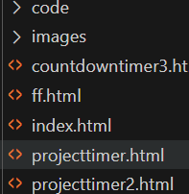

* 1. **HTML Code**

These screenshots present the HTML code for our Ping Pong project, revealing the layout and content of our web pages in a code format.

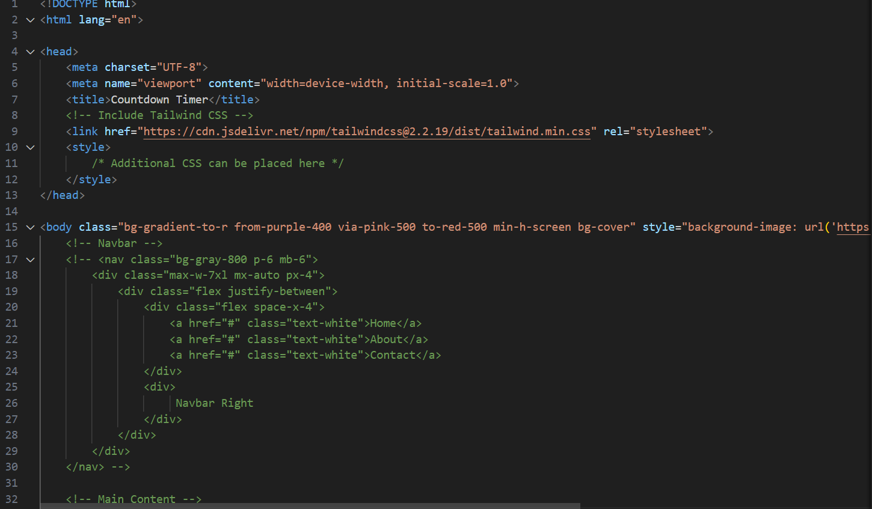

* 1. **JavaScript Code**

This screenshot exhibits the JS code for our Ping Pong App project, illustrating the different functions and events we trigger according to different scenarios.

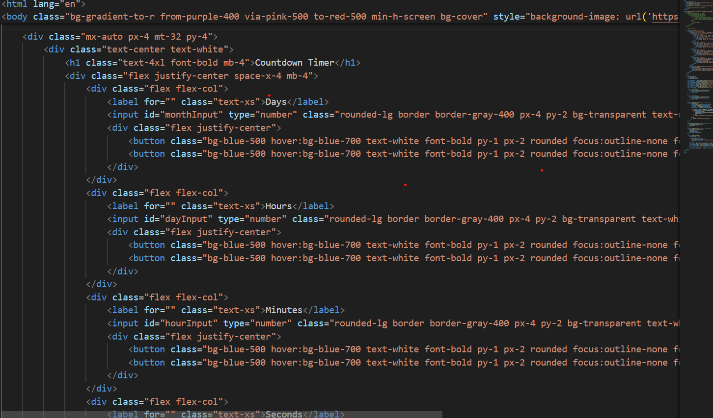 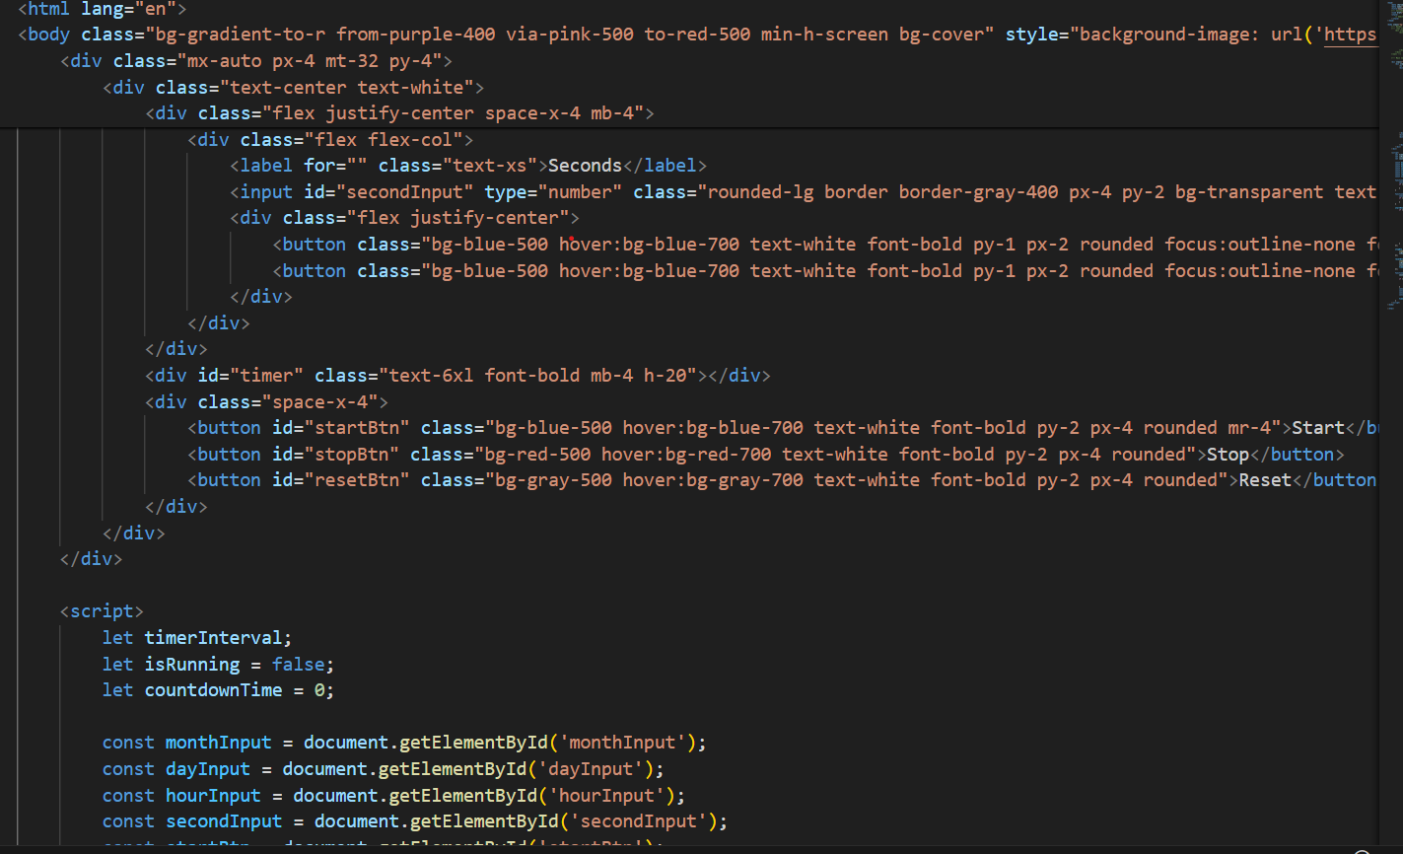

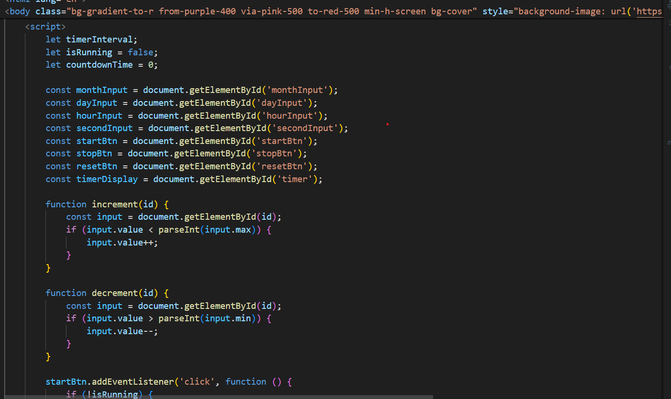

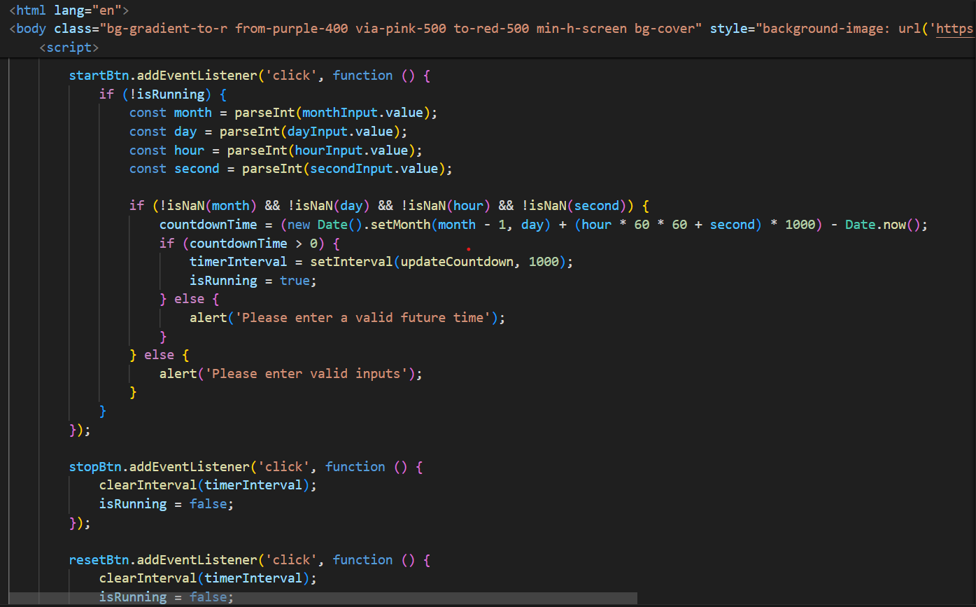

# Results

**Project Screenshots for all scenarios:**

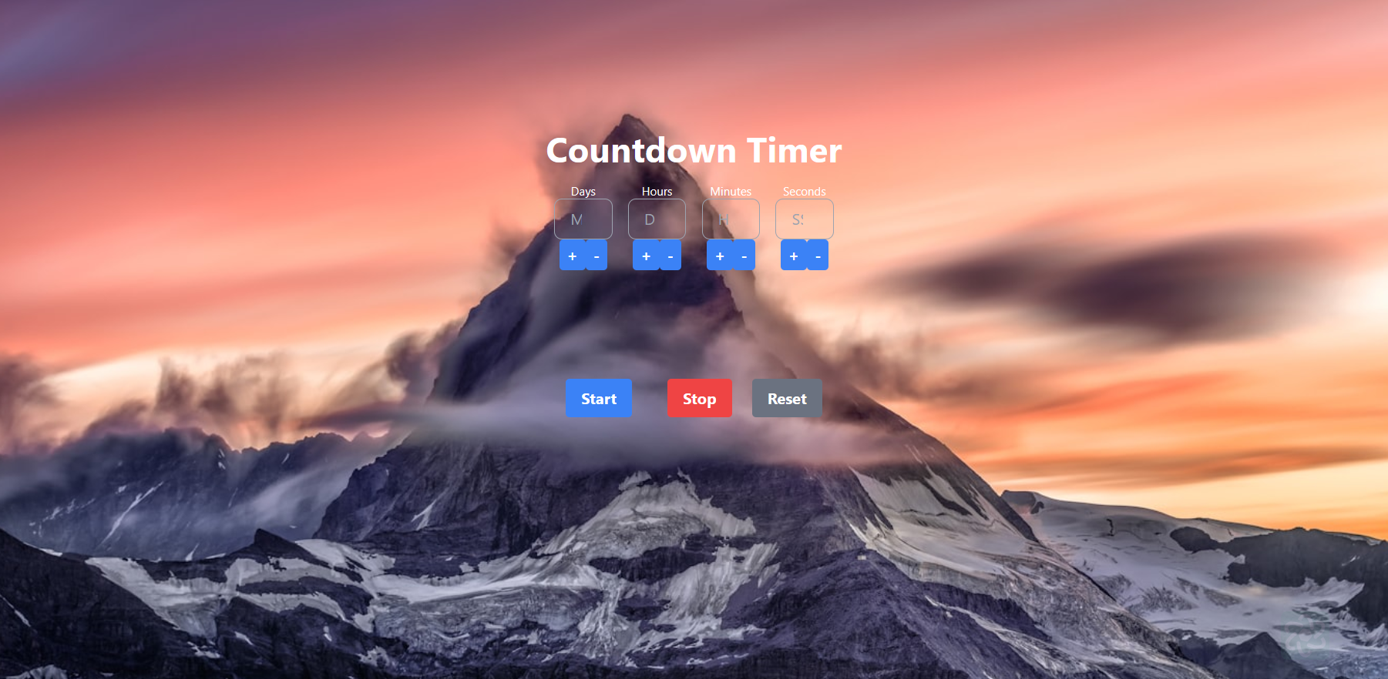 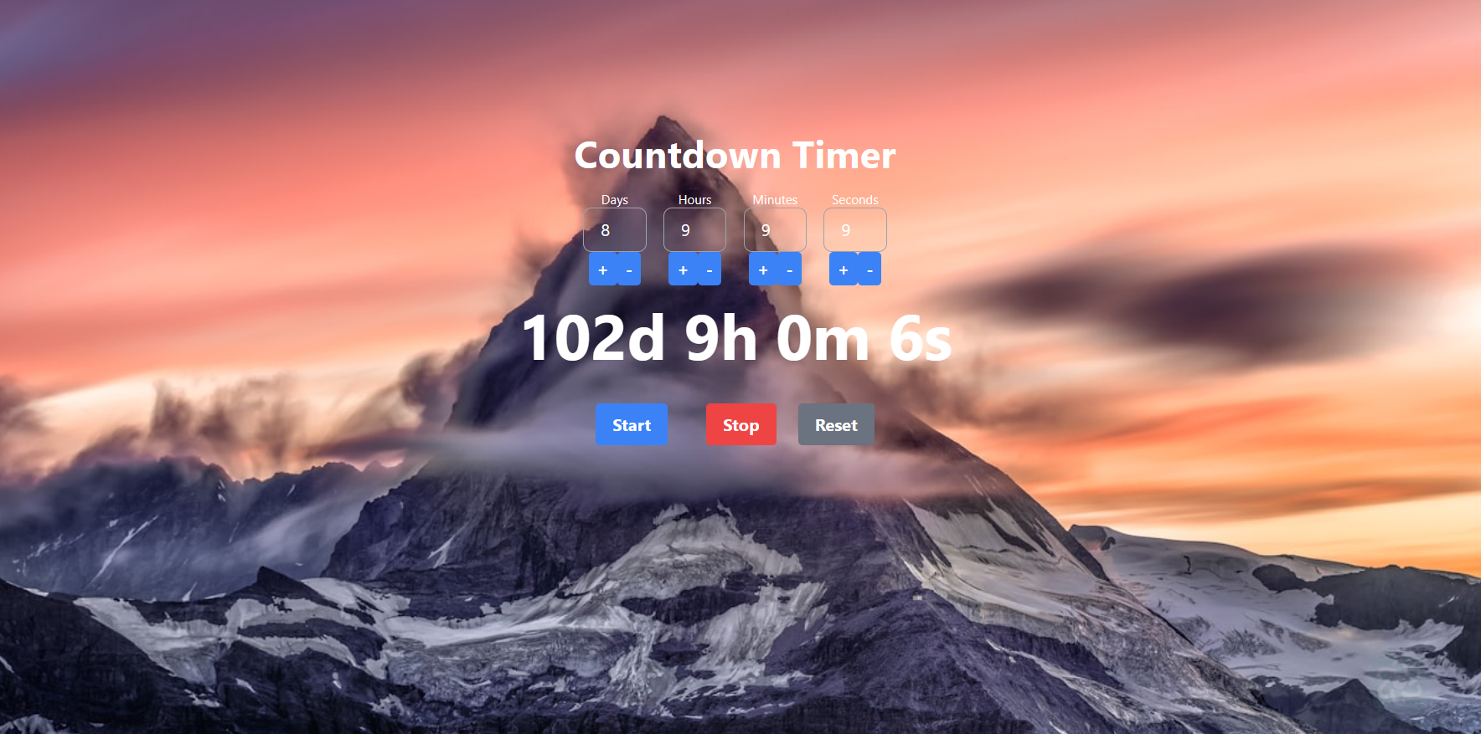

Static View

# References

* **HTML, CSS, and JavaScript Documentation:**
* **Mozilla Developer Network (MDN) - HTML:** https://developer.mozilla.org/enUS/docs/Web/HTML
* **Mozilla Developer Network (MDN) JavaScript:**

https://developer.mozilla.org/en-US/docs/Web/JavaScript

* **Tailwind Documentation:**
* **Tailwind Official Documentation:**

https://tailwindcss.com/

* **GeeksForGeeks Tailwind Tutorial:**

https://www.geeksforgeeks.org/tailwind-css/